**B: Basic Laboratory (Digital Logic)**

**Contents**

1. EXPERIMENT SETUP AND GATES
2. AND, NAND, OR, NOR LOGIC GATES
3. BOOLEAN ALGEBRA
4. KARNAUGH MAPS
5. SR, D-LATCHES EXPERIMENT
6. JK/T FLIP FLOP
7. SYNCHRONOUS COUNTERS
8. 7 SEGMENT WITH COUNTER
9. ASYNCHRONOUS COUNTERS

B-1.

Experiment and Gates

**OBJECTIVES:**

The objective of this lab is to become familiar with the basic test equipment in the laboratory that will be used to take measurements and trouble shoot your breadboard designs going forward. Specifically, this lab will give experience using a real-time oscilloscope and an arbitrary waveform generator and what affects the signals levels from the waveforms.

READING:

SUMMARY OF THEORY:

Guide to Assemble

In this section we describe the use of the breadboard and give basic hints about the wiring process needed to power up and interconnect your circuits. Assembling circuits on your breadboard is a fast and easy process once you get used to it. To assemble your circuit first select the chips that you need, insert them in the breadboard, wire up the power and ground connections as described in the next section and next wire the logic elements according to the circuit connections that you obtained from the design process.

Before you insert a chip into the breadboard, make sure it is properly oriented, and that when you press it down the pins of the chip actually enter the holes and do not bend underneath the chip package. When wiring, be careful to hit the right hole needed in the connection, because this is one of the most common mistakes found to cause an error in your projects.

Breadboard

In order to assemble the lab experiments, every student should use his/her own breadboard (similar to the one shown in Figure 1). The breadboard has 8 sets of rows (1) and (2), consisting of 25 holes that are horizontally interconnected, and groups of columns (3) and (4), consisting of 5 holes that are vertically interconnected. The rows and columns are used to hold chips and wires, and interconnect them as shown in Figures 7 and 8.

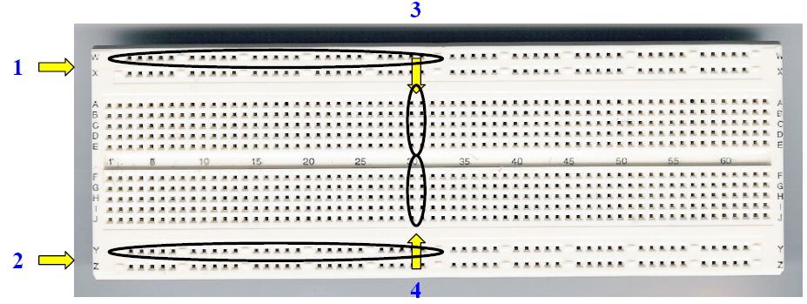

Figure 1 Breadboard

Also, in Figures 2 and 3 we show two typical ways to distribute power (1), and ground (2) signals that are recommended in order to avoid noise in your circuit, and assure good performance from the chips. The banana plugs (3), if available, can be used to connect your breadboard to an external power supply.

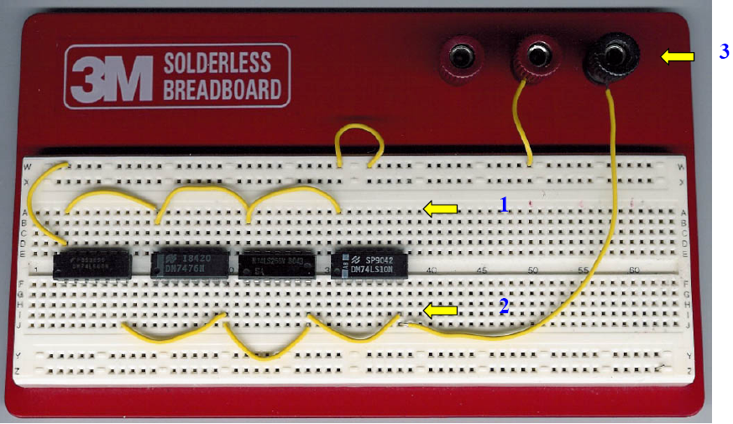

Figure 2 Power and Ground Connection (method A)

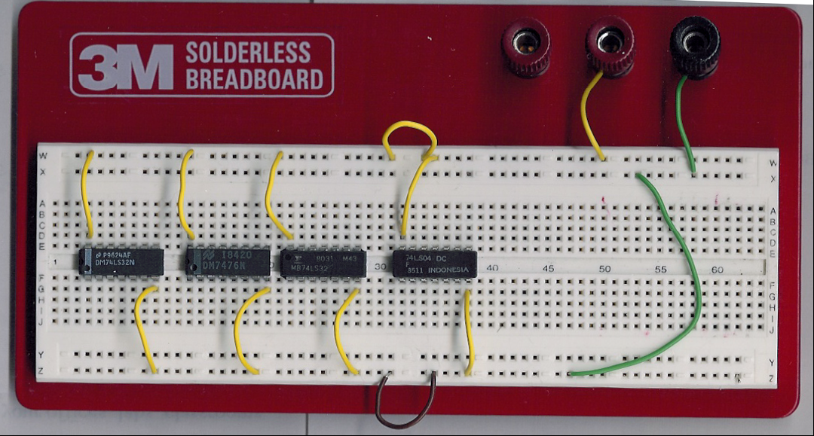

Figure 3 Power and Ground Connection (method B)

TTL Packages Description

The chips or packages that will be used to build the experiments belong to the TTL logic family, and they are referred as the 74LSXX family, where the XX is a number that indicates the specific kind of gate or function. The main characteristics for some typical logic gates packages are shown in Figures 4 and 5 next.

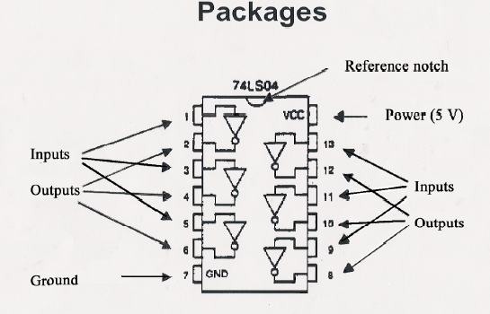

Figure 4 Inverter (NOT) gate pin distribution

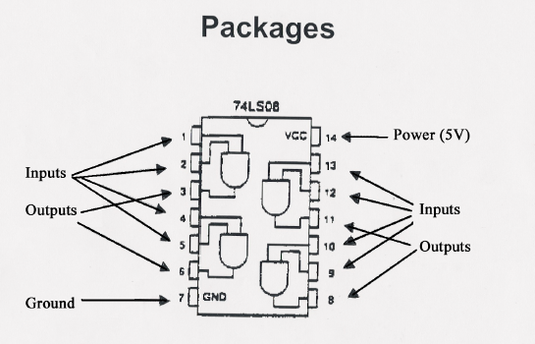

Figure 5 AND gate pin distribution

Most commonly used TTL devices have their power and ground connections on pins 14 and 7 respectively, however verify this information before using some special function or uncommon packages. Also, all packages have a notch or mark that indicates the proper orientation of the device. From this mark each pin is numbered in a counter clockwise direction. The specific function that each chip performs is typically described using function tables, logic tables or logic diagrams as the ones shown in Figure 7.

|  |  |
| --- | --- |
| Figure 6 pin configuration | Figure 7 Logic Diagram |

|  |  |
| --- | --- |
| Figure 8 Functional Diagram | Figure 9 IEC logic Symbol |

Diagrams and Labeling

Using the pin distribution for the TTL packages given by the manufacturer, and once that you design the circuit that performs the desired logic function, the next step is to wire up the circuit that implements this function. Because every chip has a different number of gates, a good implementation step is to make a diagram for the circuit and label all inputs, outputs and gates in the way shown in Figure 10. By doing this the wiring and testing process will be done very easily in the lab.

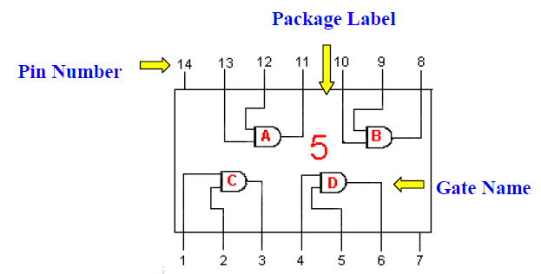

Figure 10 Package, gate and pin labeling

There are many methods than can be used to label a circuit. In this manual we show only one that is easy to understand and implement. In this method, every input and output pin shown in the diagram shows the respective pin number that corresponds to the gate in its package. The gates are labeled using a letter and a number. The letter labels a specific gate inside the package, and the number labels the package corresponding to its order.

Another important characteristic that can be noticed from this diagram is that the flow of interconnections and signals follows a left to right direction. This means that typically

In the Table 1, we show the TTL inventory for the chips available in the lab that can be used in the implementation of your circuits. For some lab experiments you will be informed about which chips you can exclusively use for that project in particular, otherwise you can use any package that is given in the list. Also, a quick reference guide for some of the most common devices is shown in Table 1.

Table 1 TTL Chip Inventory

|  |  |  |  |
| --- | --- | --- | --- |
| **NAME** | **FUNCTION** | **NAME** | **FUNCTION** |
| 74LS139 | DUAL 2 → 4 DECODER | 74LS00 | 2 INPUT NAND |
| 74LS148 | 8 → 3 DECODER | 74LS02 | 2 INPUT NOR |
| 74LS151 | 8 → 1 MULTIPLEXER | 74LS04 | INVERTER |
| 74LS153 | 4 → 1 MULTIPLEXER | 74LS08 | 2 INPUT AND |
| 74LS155 | 2 → 4 DECODER | 74LS10 | 3 INPUT NAND |
| 74LS157 | 2 → 1 MULTIPLEXER | 74LS11 | 3 INPUT AND |
| 74LS161 | 4 BIT COUNTER | 74LS20 | 4 INPUT NAND |
| 74LS163 | 4 BIT COUNTER | 74LS25 | 4 INPUT NOR |
| 74LS164 | 8 BIT SHIFT REG | 74LS27 | 3 INPUT NOR |
| 74LS169 | 4 BIT COUNTER | 74LS30 | 8 INPUT NAND |
| 74LS170 | 4 x 4 REGISTER | 74LS32 | 2 INPUT OR |
| 74LS174 | HEX D F-F | 74LS42 | 4 → 10 DECODER |
| 74LS175 | QUAD D F-F | 74LS74 | DUAL D F-F |
| 74LS191 | 4 BIT COUNTER | 74LS75 | QUAD LATCH |
| 74LS193 | 4 BIT COUNTER | 74LS83 | 4 BIT ADDER |
| 74LS194 | 4 BIT SHIFT REG | 74LS85 | 4 BIT COMPARATOR |
| 74LS195 | 4 BIT SHIFT REG | 74LS86 | 2 INPUT XOR |
| 74LS244 | OCTAL BUFFER | 74LS93 | 4 BIT COUNTER |
| 74LS259 | 8 BIT ADDER | 74LS95 | 4 BIT SHIFT REG |
| 74LS283 | 4 BIT ADDER | 74LS109 | DUAL J-K F-F |
| 74LS373 | OCTAL LATCH | 74LS138 | 3 → 8 DECODER |

TTL Devices Electrical Characteristics

In the design of logical functions we assume that there are only two values (0 and 1), which are used to represent the state of the variables or signals. However, to implement these functions we use electric devices (called also logic gates) that use voltages to represent the 0 and 1 values. In the following discussion we describe in more detail the electrical characteristics of the TTL family of gates. The voltages that represent the two binary values are called VH (to represent a 1 or high) and VL (to represent a 0 or low), where VH > VL. The actual values of these voltages are not stable because they fluctuate due to changes in technology, temperature, loading, noise, etc. Because of this, instead of defining fixed voltage values for the 0 and 1 states, the states are given rather as a range of valid values as shown in Figure 11.

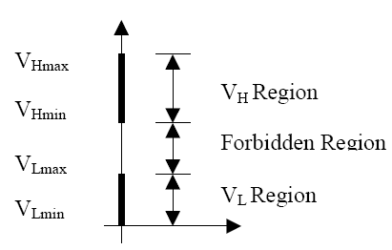

Figure 11 Valid Voltage Regions for 0 and 1 states

From the Figure 11 we notice that a valid “0” is any voltage between VL min and VLmax, and a valid “1” is any voltage between VHmax and VHmin. Any voltage between VHmin and VLmax is not allowed since the device won’t be able to recognize this voltage as valid 0 or a valid 1.

Noise Margins

Electronic circuits are constantly subjected to random noise produced by the environment, which can alter the output voltage levels produced by the gate. In Figure 12, refer to the gates G1 and G2. . In order to make sure that any TTL output is able to drive any TTL input, two different ranges of voltages are allowed to represent the high and low levels in the output than in the input. These levels are defined as shown in Figure 12. The high output voltage values ranges between 2.4 (VOHmin) and 5 V (VOHmax) and the low output voltage values ranges 0 (VOLmin) and 0.5V (VOLmax). On the other hand, the values for the high input voltage ranges between 2 (VIHmin) and 5 V (VIHmax) and the low input range allows 0 (VILmin) to 0.8 (VILmax) to be recognized as valid values.

Consider the case when G1 produces its maximum low voltage VOLmax. The presence of noise may alter the voltage level, but as long as it remains less than VILmax it will be interpreted correctly by G2. The ability to tolerate noise without affecting the correct operation of the circuit is known as noise margin. For the low output voltage, the noise margin is defined as:

NML = VIL – VOL

In the same way, when G1 produces its minimum high output voltage VOHmin, noise can alter the voltage level, but as long as the voltage is greater than VIHmin, the state value will be interpreted correctly. For this case the noise margin is defined as:

NMH = VOH – VIH

In Figure 13 we show the two typical TTL gates interconnected and show how this connection is used to calculate the noise margin. Table shows these values.

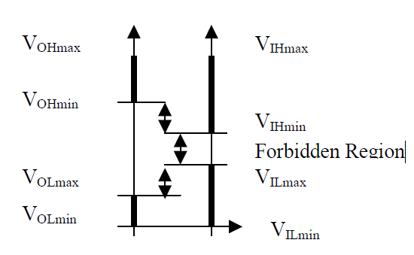

Figure 12 Noise Margin Calculation Relationship

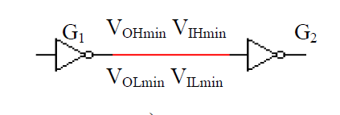

(a)

|  |  |  |
| --- | --- | --- |
| **Logical Level** | **Signal Voltage** | **Noise Margin** |
| High | VOH min= 2.4 V  VIH min = 2.0 V | 0.4 V |
| Low | VOLmax = 0.4 V  VILmax = 0.8 V | 0.4 V |

(b)

Figure 13 a) Noise Margin Calculation Circuit, and b)Table

Basics of Oscilloscopes

The main purpose of an oscilloscope is to graph an electrical signal as it varies over time. Most scopes produce a two-dimensional graph with time on the x-axis and voltage on the y-axis.

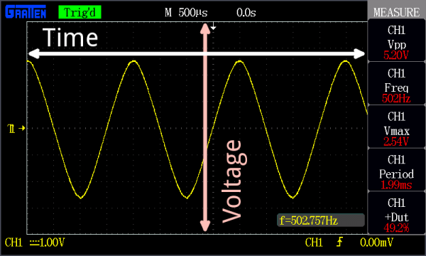

Controls surrounding the scope’s screen allow you to adjust the scale of the graph, both vertically and horizontally – allowing you to zoom in and out on a signal. There are also controls to set the trigger on the scope, which helps focus and stabilize the display.

What Can oscilloscope measure

In addition to those fundamental features, many scopes have measurement tools, which help to quickly quantify frequency, amplitude, and other waveform characteristics. In general a scope can measure both time-based and voltage-based characteristics:

**Timing characteristics**:

**Frequency and period:** Frequency is defined as the number of times per second a waveform repeats. And the period is the reciprocal of that (number of seconds each repeating waveform takes). The maximum frequency a scope can measure varies, but it’s often in the 100’s of MHz (1E6 Hz) range.

**Duty cycle:** The percentage of a period that a wave is either positive or negative (there are both positive and negative duty cycles). The [duty cycle](https://learn.sparkfun.com/tutorials/pulse-width-modulation/duty-cycle) is a ratio that tells you how long a signal is “on” versus how long it’s “off” each period.

**Rise and fall time:** Signals can’t instantaneously go from 0V to 5V, they have to smoothly rise. The duration of a wave going from a low point to a high point is called the rise time, and fall time measures the opposite. These characteristics are important when considering how fast a circuit can respond to signals.

**Voltage characteristics**:

**Amplitude:** Amplitude is a measure of the magnitude of a signal. There are a variety of amplitude measurements including peak-to-peak amplitude, which measures the absolute difference between a high and low voltage point of a signal. Peak amplitude, on the other hand, only measures how high or low a signal is past 0V.

**Maximum and minimum voltages:** The scope can tell you exactly how high and low the voltage of your signal gets.

**Mean and average voltages:** Oscilloscopes can calculate the average or mean of your signal, and it can also tell you the average of your signal’s minimum and maximum voltage.

When to Use an Oscilloscope

The oscilloscope is useful in a variety of troubleshooting and research situations, including:

* Determining the frequency and amplitude of a signal, which can be critical in debugging circuit’s input, output, or internal systems. From this, you can tell if a component in your circuit has malfunctioned.
* Identifying how much noise is in your circuit.
* Identifying the shape of a wave – sine, square, triangle, sawtooth, complex, etc.
* Quantifying phase differences between two different signals.

How to Write Report

Student need to write a Result Report after the laboratory and submit the report before the next laboratory class. The contents in the report may include as following

1. Purpose of Laboratory
2. Summary of Background Theory
3. Tools and Parts used
4. Experiment methods
5. Experiment Results
6. Observation from Experiment Results
7. Conclusion
8. Reference (if you referred)

When the student make the report, a cover page is needed as following format, and the report contents mentioned above included in following pages.

|  |
| --- |
| **Laboratory Result Report**  **Title:** *Write here the**laboratory title of the week*  Department:  Class Name:  Student No:  Student Name: |